# Mini Project : Puzzle Quest

## I. Project Introduction

The core mechanic of the game revolves around solving ***Math Puzzles.*** Each level presents the player with a short numerical or pattern-based problem, such as completing a number sequence, solving a simple equation, or finding a missing number.

**Puzzle Quest** is a cross-platform puzzle game designed for all age groups. It offers progressively challenging levels, a ranking system, achievement tracking, and frequent content updates. The game emphasizes a user-friendly experience, mental stimulation, social interaction, and accessibility. It is developed with an agile methodology, ensuring that new features are iteratively refined based on user feedback.

Example Puzzle:

"Fill in the missing number: 1, 4, 9, 16, ?, 36"

(Answer: 25)

Players input their answers through a simple **UI.** If the answer is correct, the system updates their score and progress. If incorrect, the system offers a hint after deducting from the player's hint count. Players can retry until they solve the puzzle or exit the level.

## II.  Stakeholder Analysis & Stakeholder Matrix

#### Stakeholder Matrix Documentation

|  |  |  |  |
| --- | --- | --- | --- |
| **Stakeholder** | **Interest / Power** | **Justification** | **Communication Strategy** |
| Player | High interest / Some power | Direct user of the game; their feedback guides the game’s evolution | Keep Informed |
| Product Manager | High interest / High power | Owns the product roadmap, features, and resource allocation | Engage Closely |
| Developer | High interest / Low power | Implements technical features; limited influence on prioritization | Keep Informed |
| QA Tester | Some interest / Low power | Ensures quality; not involved in core design decisions | Monitor / Minimal effort |
| Artist/Animator | Some interest / Low power | Shapes visual and audio experience | Monitor / Minimal effort |
| Moderator | Some interest / Low power | Maintains safe and friendly community environment | Monitor / Minimal effort |
| Marketing | Some interest / Some power | Promotes the game and drives user acquisition | Keep Satisfied |

#### Stakeholder Matrix

## III. Problem Statement and Objectives

### P**uzzle Quest Problem Statement**

In today’s gaming landscape, many puzzle games face difficulties in sustaining player engagement. This is largely attributed to repetitive gameplay mechanics and a lack of meaningful progression systems. Players often encounter frustration when faced with challenging levels that offer little to no in-game support, leading to increased dropout rates. Additionally, the absence of key features—such as well-optimized leaderboards, robust social interaction, and comprehensive accessibility options—further diminishes the overall user experience. To address these challenges, a successful solution must deliver puzzles that are both challenging and rewarding, provide effective in-game assistance, and foster a socially engaging and inclusive environment that promotes long-term player satisfaction.

### **Objectives of Puzzle Quest Game System**

* Provide a variety of puzzles with increasing difficulty to sustain player interest.
* Implement a smart hint system to support players during challenging levels.
* Enable real-time leaderboards, achievements, and social sharing features.
* Incorporate accessibility options such as colorblind mode and customizable UI.

#### RACI Matrix

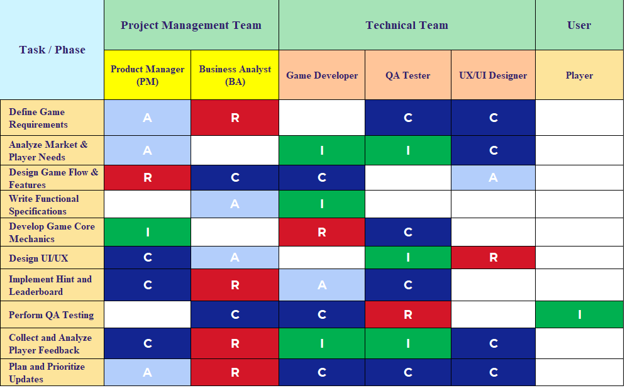

**A = Accountable**

**R = Responsible**

**I = Informed**

**C = Consulter**

Features of New System

|  |  |  |
| --- | --- | --- |
|  |  |  |
|  |  |  |
|  |  |  |
|  |  |  |
|  |  |  |
|  |  |  |
|  |  |  |
|  |  |  |

## IV. User Stories

### Players

|  |  |  |  |  |
| --- | --- | --- | --- | --- |
| **Epic** | **Title** | **MoSCoW** | **User Stories** | **Success Criteria** |
| **Puzzle Interaction** | Puzzle Selection | Must | As a player, I want to browse and select puzzles by difficulty or topic | Player can view and filter the puzzle list by topic and difficulty |
| Puzzle Completion | Must | As a player, I want to solve a puzzle and receive instant feedback | Player is notified immediately whether the answer is correct or not |
| Puzzle Hint | Should | As a player, I want to request a hint when I get stuck on a puzzle | Player can request a hint with a cooldown or limited count |
| Puzzle Retry | Could | As a player, I want to retry puzzles I previously failed | Player can re‑attempt failed puzzles from their history |
| **Player Progress** | Achievements | Should | As a player, I want to unlock badges for reaching puzzle milestones | Badges and achievements are awarded correctly for each milestone |
| Leaderboard | Could | As a player, I want to compare my score with others on a leaderboard | Leaderboard displays top players sorted by score and time taken |
| **User Experience** | Daily Challenge | Would | As a player, I want to play a new daily challenge puzzle | Daily challenge is available once per day and tracked correctly |
| Profile & Stats | Must | As a player, I want to view my profile with name, avatar, and puzzle stats | Player profile shows avatar, total solved, success rate, and badges |
| **Support & Feedback** | Report a Puzzle | Should | As a player, I want to report broken or unfair puzzles | Players can flag puzzles, and reports are sent to admin for review |
| Send feedback | Could | As a player, I want to send general feedback or improvement suggestions | Player can submit feedback through an in‑app form |
| Multi-Device Sync | Would | As a player, I want my progress to sync across all my devices | Puzzle progress and stats remain consistent when switching devices |

### Other Roles

|  |  |  |  |  |
| --- | --- | --- | --- | --- |
| **Epic** | **Title** | **MoSCoW** | **User Stories** | **Success Criteria** |
| **Analytics**  **& Insights** | Player Behavior | Must | As a Project Manager, I want dashboards showing player behavior and trends | PM can view metrics like DAU, level completion rate, puzzle difficulty use |
| Filter  by Mode/Time | Should | As a PM, I want to filter data by time range and puzzle type | Dashboards allow filtering by custom date ranges and categories |
| **QA & Testing** | In-Game Bug Reporting | Must | As a QA tester, I want bugs to include screenshots for faster debugging | In‑game bug reports allow attaching annotated screenshots |
| Test Tracking | Could | |  | | --- | |  |  |  | | --- | | As a QA tester, I want to log test sessions and their outcomes | | QA can tag builds, mark passed/failed puzzles, and log notes |
| **Developer Tools** | Puzzle  Authoring Tool | Must | As a game dev, I want a tool to easily create and preview puzzles | Dev can upload puzzles with preview, test, and publish capabilities |
| |  | | --- | |  |  |  | | --- | | Version Control | | Should | As a developer, I want to track puzzle changes across versions | Devs can rollback, view diffs, and restore previous puzzle states |

#### Features of New Puzzle System

|  |  |  |
| --- | --- | --- |
| **Puzzle Navigation** | **Player Profile & Account** | **Gameplay & Support** |
| Puzzle search by category/difficulty | Player profile (avatar, rank, achievements) | Hint system with cooldown |
| Puzzle preview and difficulty rating | Account creation and login (with email confirmation) | In-game chat/support for technical issues |
| Recently played / favorite puzzles | Cloud sync across multiple devices | Push notifications for new puzzles and events |
| Puzzle filtering (time limit, type) | Puzzle completion history | Daily puzzle reminders with time-based tracking |
| Add puzzles to play-later list | Leaderboard participation toggle | Report a puzzle (e.g. too hard / broken) |
| Puzzle categories (Math, Logic, etc.) | Language and accessibility settings | Auto-save progress and resume feature |
| Featured and trending puzzles | XP and level tracking | Optional voice hint support (future release) |